Specification by Example (SbE)

What is Specification by Example (SbE)
# Source: AI Source: Provided by: [Data Path: Persons Table -> ID Column: 1, Name_En Column: Motasem Essam] -> From: [ChatGPT] on [8/24/2025]
Specification by Example (SbE) is a collaboration-based approach to defining requirements and tests using real, concrete examples instead of abstract descriptions.
It ensures that requirements, tests, and documentation are all based on the same examples, reducing misunderstandings between business stakeholders, developers, and testers.

🔑 Key Characteristics of SbE
# Source: AI Source: Provided by: [Data Path: Persons Table -> ID Column: 1, Name_En Column: Motasem Essam] -> From: [ChatGPT] on [8/24/2025]
- Examples Instead of Abstract Rules
  - Instead of vague requirements (“System must support discounts”), SbE uses specific examples:
    - If a customer buys 3 books, they get a 10% discount.
- Shared Understanding
  - Stakeholders (business, dev, QA) collaborate to define examples together.
- Living Documentation
  - These examples are turned into executable tests, which double as always up-to-date documentation.
- Close Relation to BDD/ATDD
  - SbE is the underlying principle behind approaches like BDD and ATDD.

📖 Example of SbE

Requirement (abstract)
# Source: AI Source: Provided by: [Data Path: Persons Table -> ID Column: 1, Name_En Column: Motasem Essam] -> From: [ChatGPT] on [8/24/2025]
The system should calculate discounts based on the number of items purchased.

Specification by Example
# Source: AI Source: Provided by: [Data Path: Persons Table -> ID Column: 1, Name_En Column: Motasem Essam] -> From: [ChatGPT] on [8/24/2025]

Items purchased | Discount applied
1–2 | 0%
3–5 | 10%
6+ | 20%
- This table becomes both requirement and acceptance test case.
- Developers implement logic to pass these tests.

✅ Benefits of SbE
# Source: AI Source: Provided by: [Data Path: Persons Table -> ID Column: 1, Name_En Column: Motasem Essam] -> From: [ChatGPT] on [8/24/2025]
- Eliminates ambiguity in requirements.
- Builds shared understanding between business and technical teams.
- Reduces rework caused by unclear requirements.
- Creates living documentation (tests double as specs).
- Ensures alignment between requirements, tests, and implementation.

⚠️ Challenges
# Source: AI Source: Provided by: [Data Path: Persons Table -> ID Column: 1, Name_En Column: Motasem Essam] -> From: [ChatGPT] on [8/24/2025]
- Requires strong collaboration among stakeholders.
- Needs discipline to maintain examples as the system evolves.
- Risk of too many examples making tests hard to manage.

🔄 SbE vs BDD vs ATDD
# Source: AI Source: Provided by: [Data Path: Persons Table -> ID Column: 1, Name_En Column: Motasem Essam] -> From: [ChatGPT] on [8/24/2025]
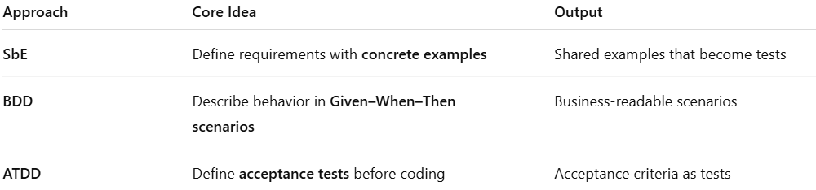
Approach | Core Idea | Output
SbE | Define requirements with concrete examples | Shared examples that become tests
BDD | Describe behavior in Given–When–Then scenarios | Business-readable scenarios
ATDD | Define acceptance tests before coding | Acceptance criteria as tests
👉 SbE is the foundation; BDD and ATDD are practical implementations of it.

⚖️ Summary:
# Source: AI Source: Provided by: [Data Path: Persons Table -> ID Column: 1, Name_En Column: Motasem Essam] -> From: [ChatGPT] on [8/24/2025]
Specification by Example (SbE) = requirements, tests, and documentation are defined using concrete, shared examples, ensuring clarity and alignment across the team.

